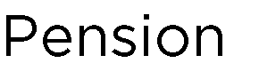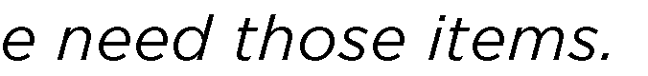
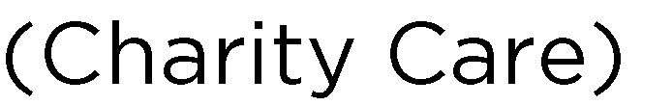

□ □
□ □
□ □ □
□ □ | □ □
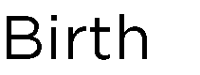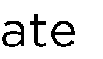

 | 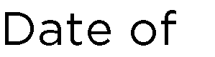 |  | 
      
 
   

